# Steps to fix Currency and Date format.

1. First Open Control Panel.

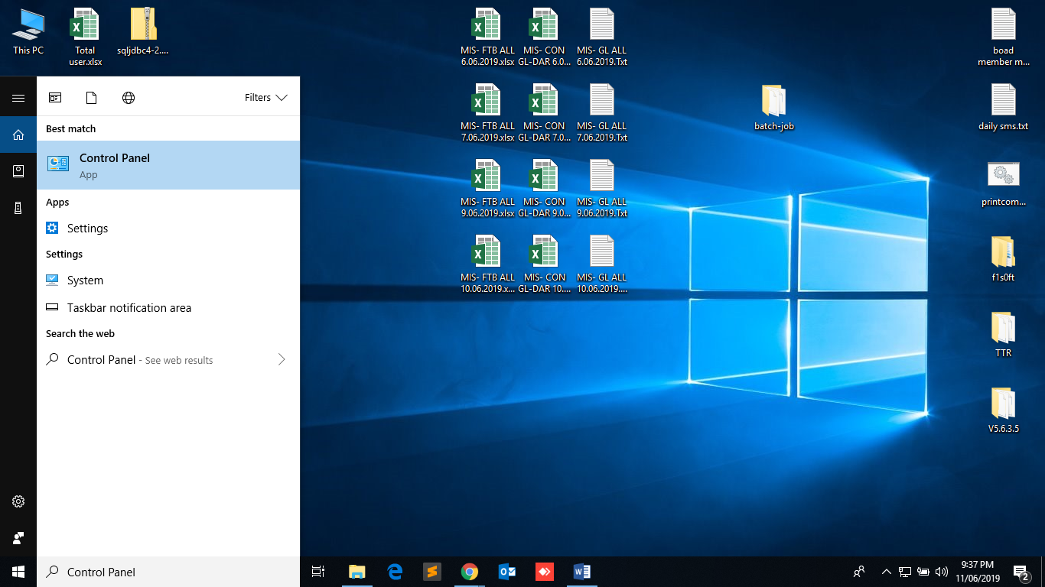

1. It might be opened in 2 different forms. Click on the Region if all items are displayed as below and skip to Step 5.

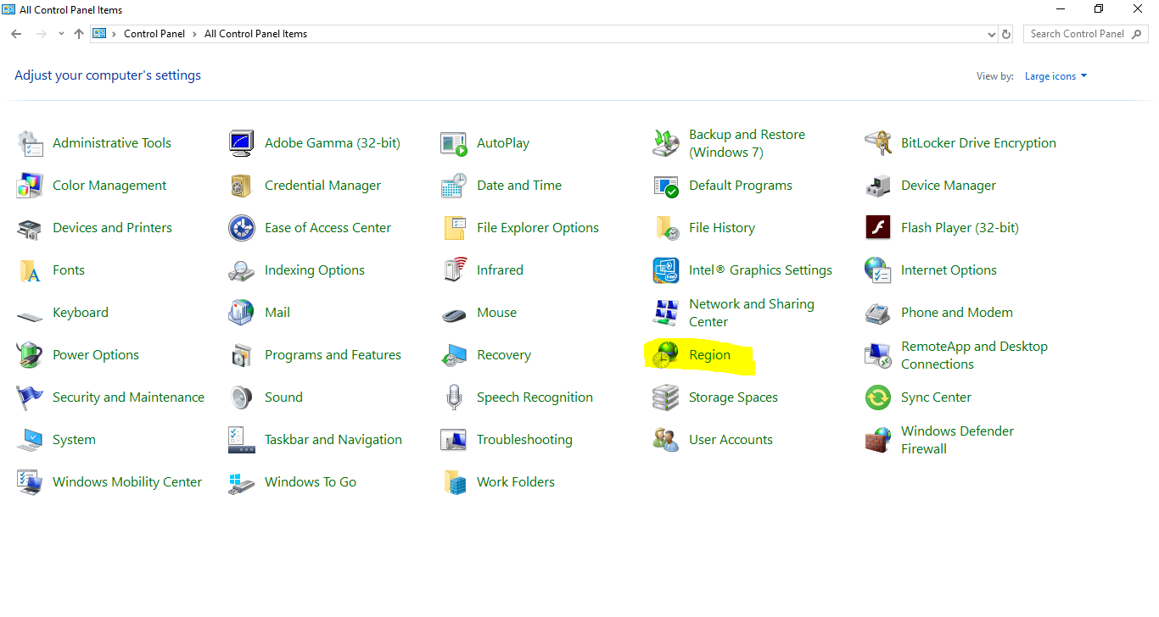

1. Click “Clock and Region”

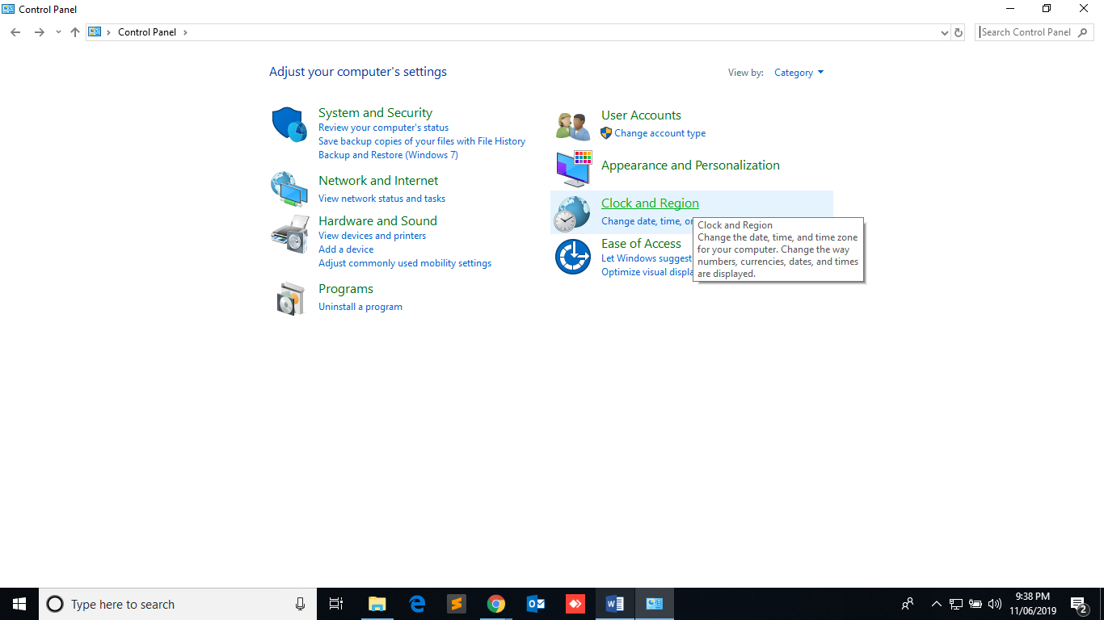

1. Click “Change date time or number formats”

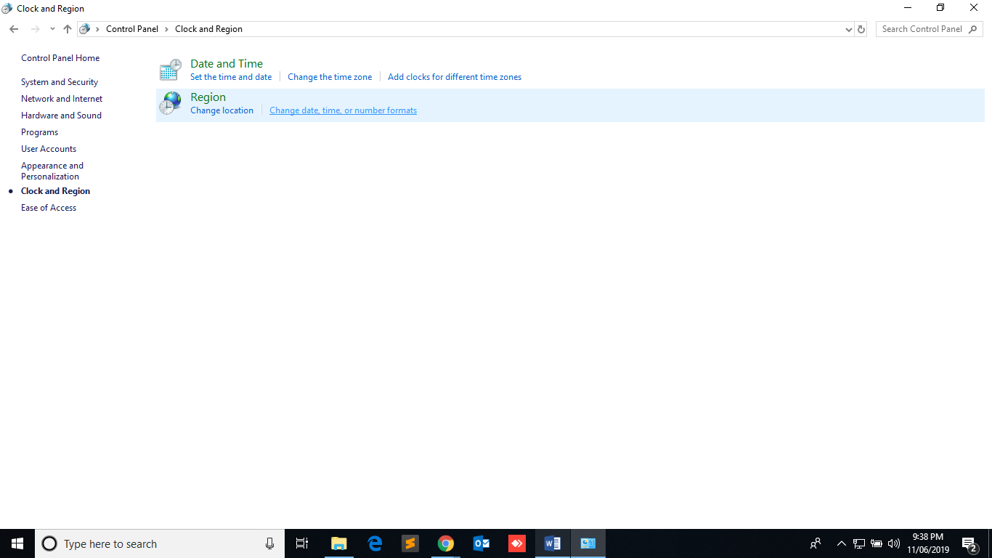

1. Change the date to the given format below . To change Currency click Additional Settings .

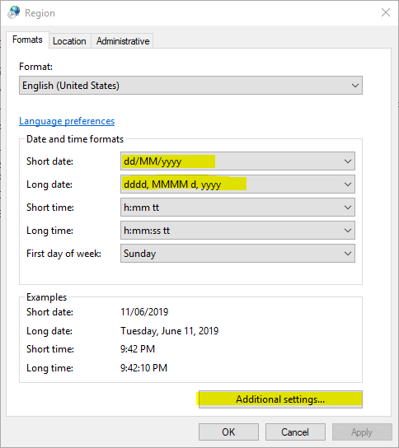

1. Remove the value and press SPACEBAR and press apply and OK.

